Starters Guide – Programming Alice 2 in Visual Studio
Requirements:
- Visual Studio 2010
- Alice 2 source code
- Latest version of Alice 2

Creating a project in Visual Studio 2010
- Create a new Project.
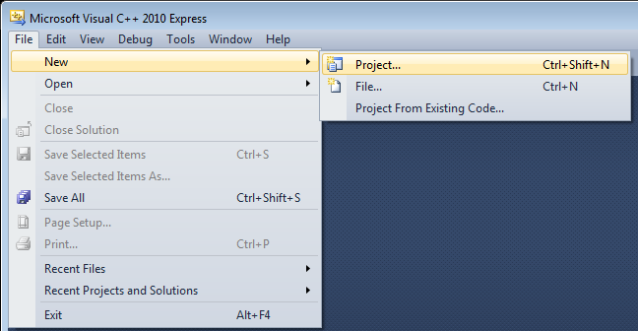
- Select Empty Project from the Visual C++, General section, and then name your project.
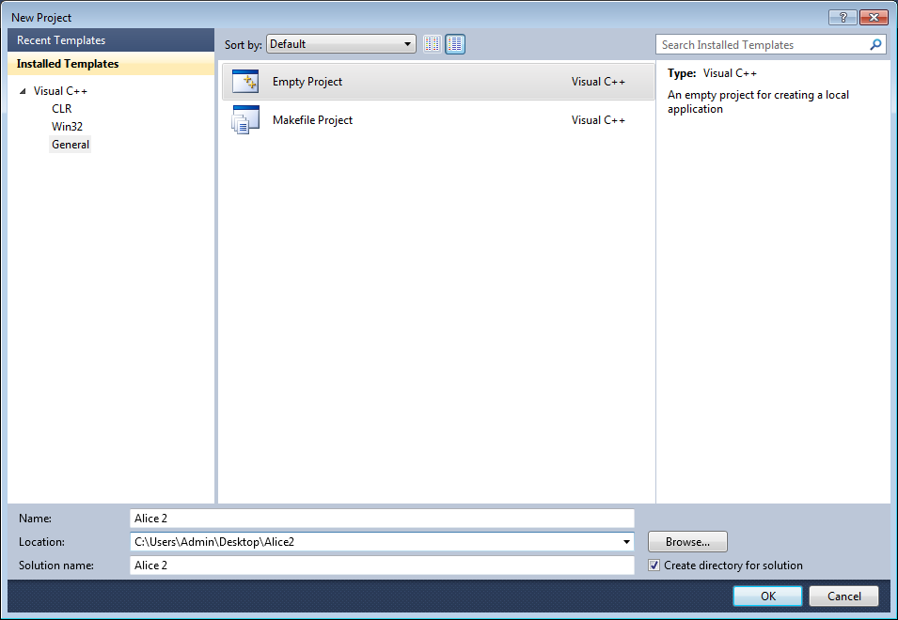
- Once your project is created, you will see three folders labeled Header Files, Resource Files, and Source Files. Right click on the Source Files folder, select Add and click Existing Item.
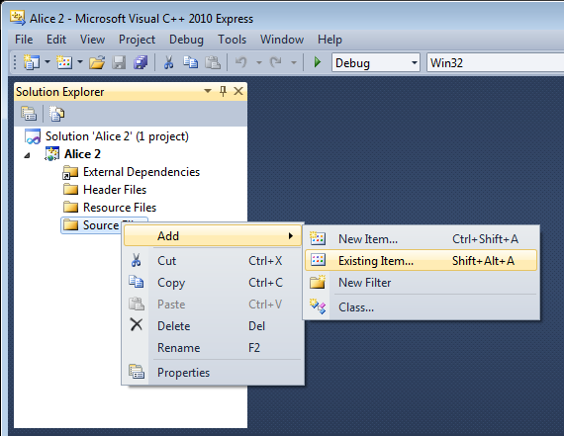
- Browse to your Alice 2 Source folder and add launcher.cpp to your Alice project.
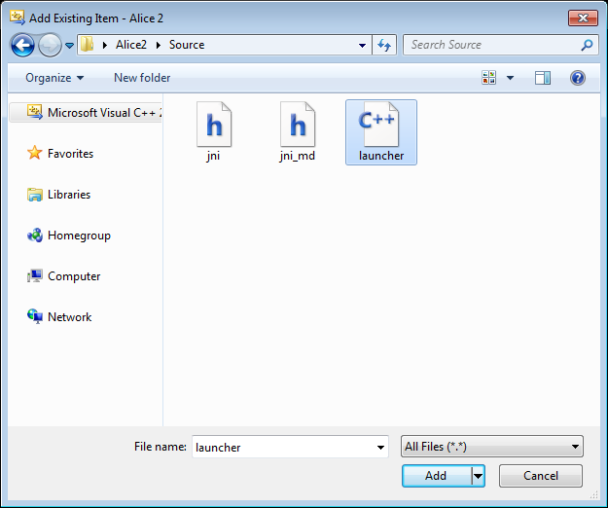
- Right click on the Resource Files folder, select Add and click Existing Item.
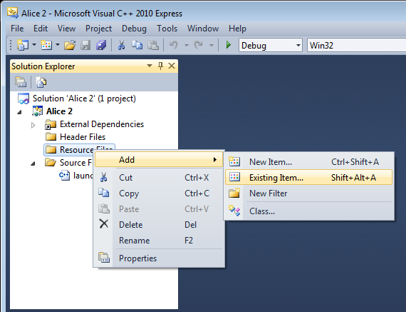
- Browse to your Alice 2 Resource folder and the icons and resource.h file to your Alice project.
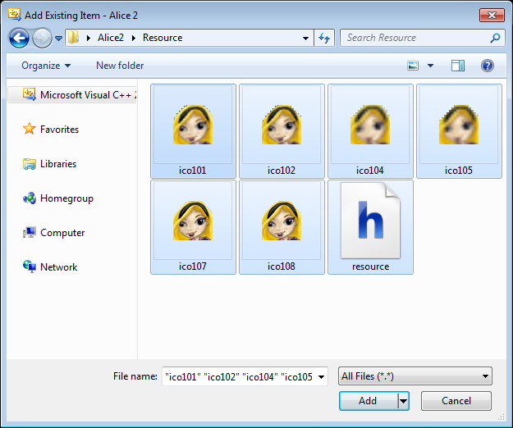
- Right click on your Alice project and click Properties.
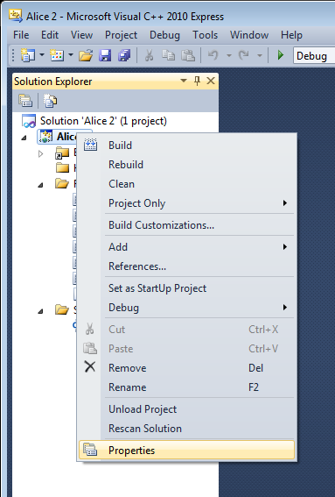
- In the Debugging section, change the Working Directory to the location of your Alice 2 Required folder.
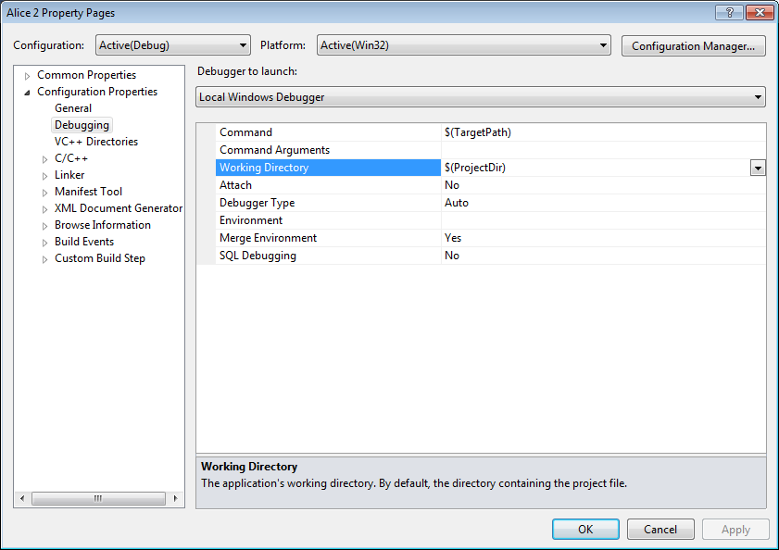
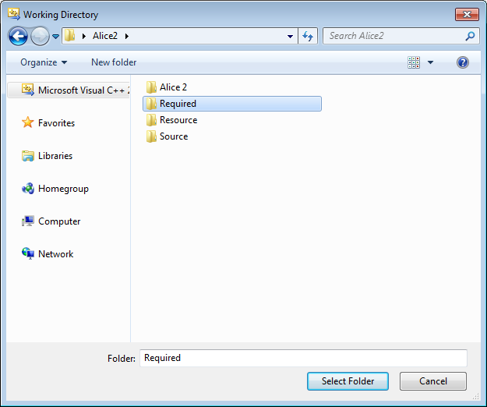
- In the C/C++, General section, include your Alice 2 source folder in the Additional Include Directories section. Your source folder contains two JNI header files that are required to compile your Alice 2 C++ project.
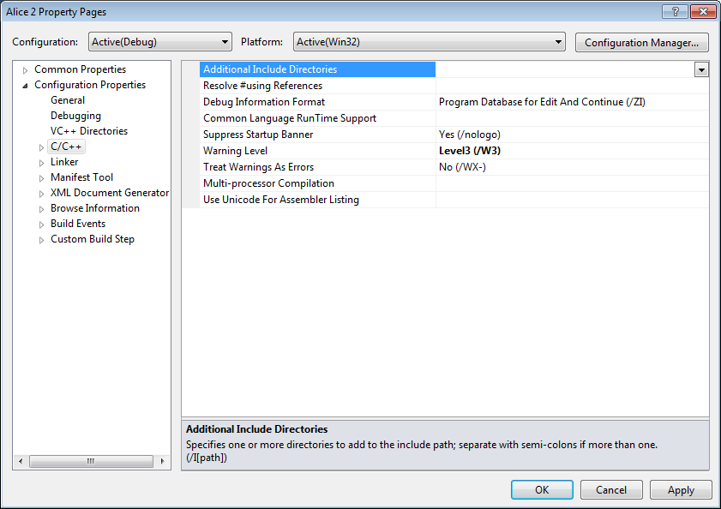
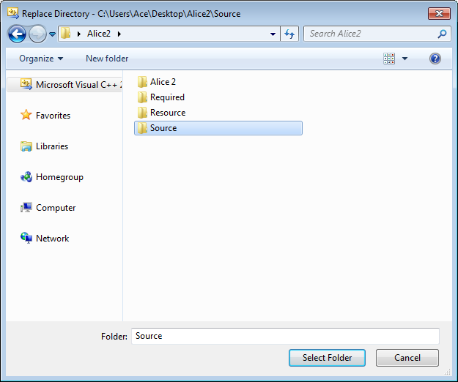
- In the C/C++, Code Generation section, change the Runtime Library to Multi-threaded (/MT), so the compiled executable (exe) will be compiled will all the required system libraries (dll).
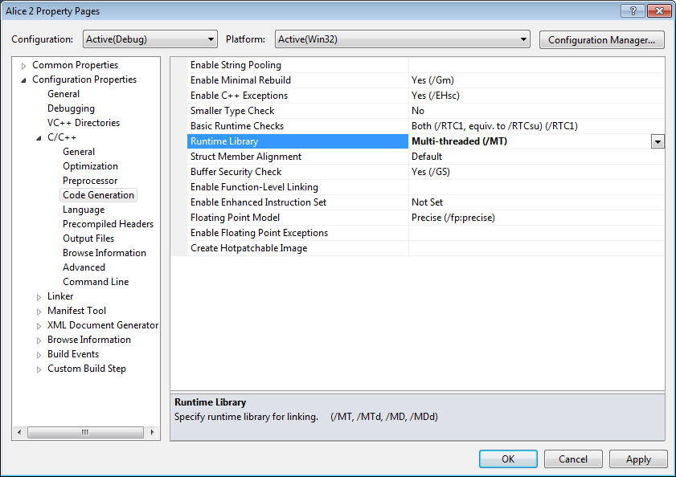
- Click the play 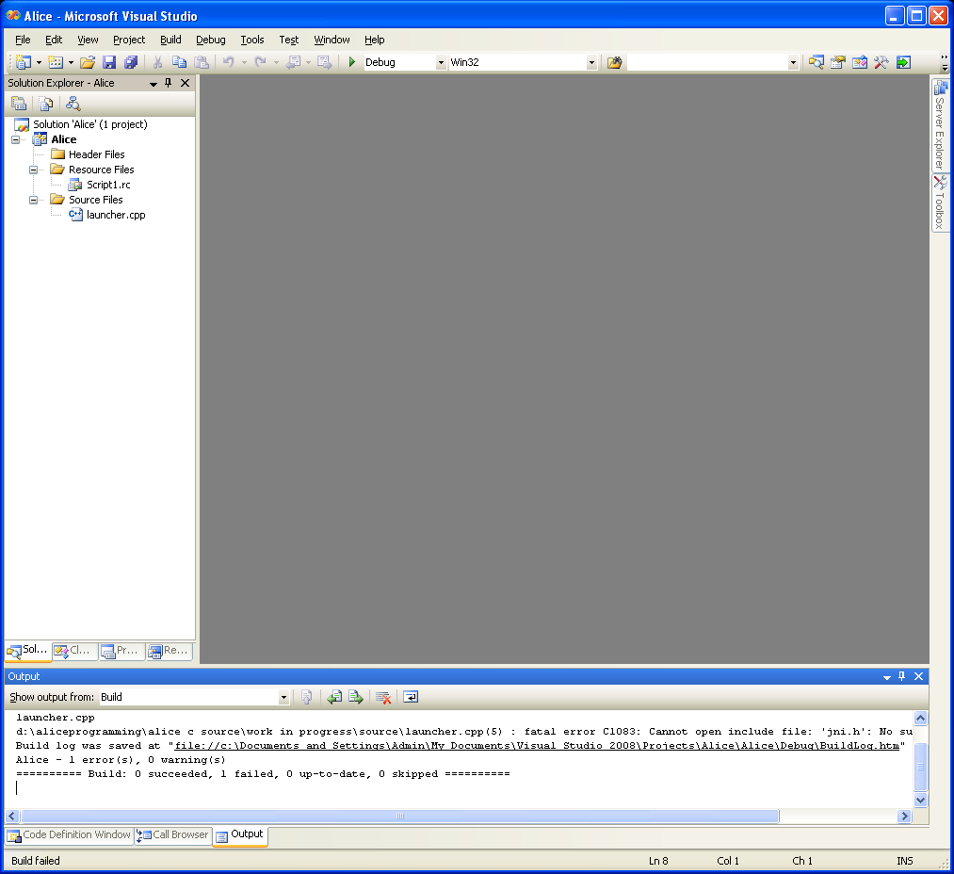 button to debug your project.
